90

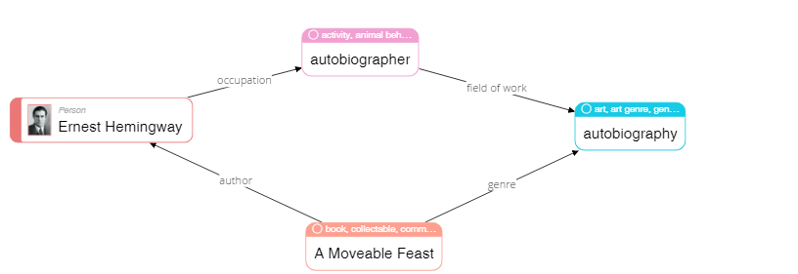

|  |
| --- |
| **Please describe shortly what you see on this diagram? Pay attention only to that information that is understandable or has sense for you.** |
| THe book “A moveable feast” is written as autobiography, authored by Ernest Hemingway, who is autobiographer by occupation |

68

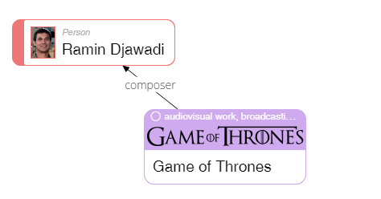

|  |
| --- |
| **Please describe shortly what you see on this diagram? Pay attention only to that information that is understandable or has sense for you.** |
| Is this the man who wrote the music for Game of Thrones? |

23

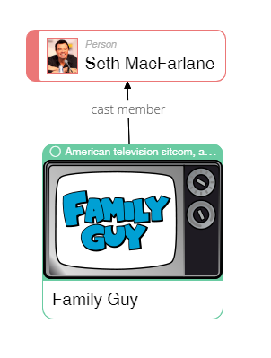

|  |
| --- |
| **Please describe shortly what you see on this diagram? Pay attention only to that information that is understandable or has sense for you.** |
| This is the actor of american sitcom “Family Guy” |

50

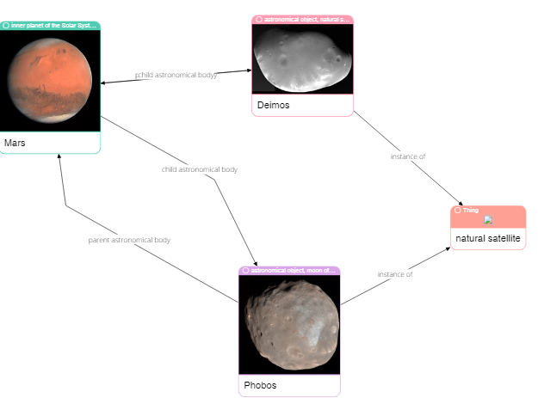

|  |
| --- |
| **Please describe shortly what you see on this diagram? Pay attention only to that information that is understandable or has sense for you.** |
| I see some relation between the astronomical bodies, Mars the planet and natural satellites |

62

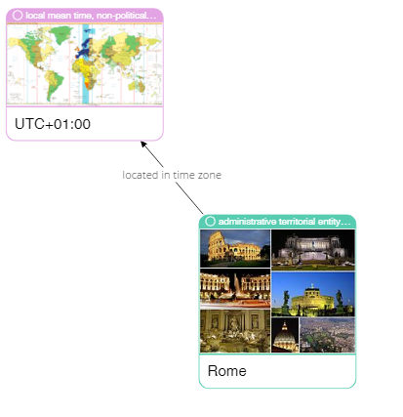

|  |
| --- |
| **Please describe shortly what you see on this diagram? Pay attention only to that information that is understandable or has sense for you.** |
| The location of Rome on the map with the explicit mention of time zone. With a photo of its main landmarks |

75

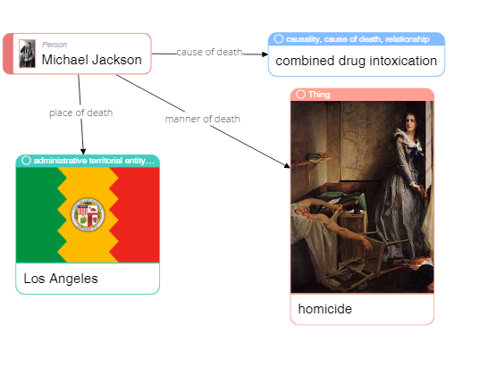

|  |
| --- |
| **Please describe shortly what you see on this diagram? Pay attention only to that information that is understandable or has sense for you.** |
| hese are the facts about the death of Michael Jackson: where, how, the cause of death. Without details. |

79

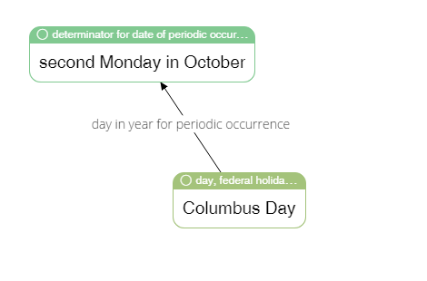

|  |
| --- |
| **Please describe shortly what you see on this diagram? Pay attention only to that information that is understandable or has sense for you.** |
| The repetitiveness of federal holiday “Columbus day” - the second Monday of October |

65

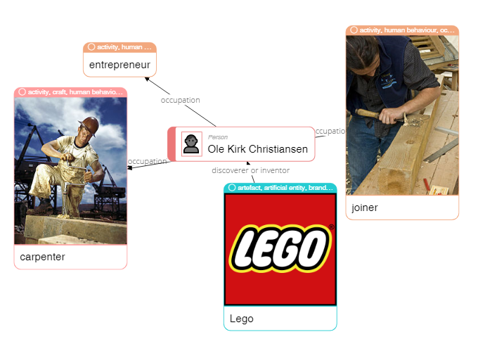

|  |
| --- |
| **Please describe shortly what you see on this diagram? Pay attention only to that information that is understandable or has sense for you.** |
| This man is a carpenter, joiner, entrepreneur. Inventor of Lego? |

4

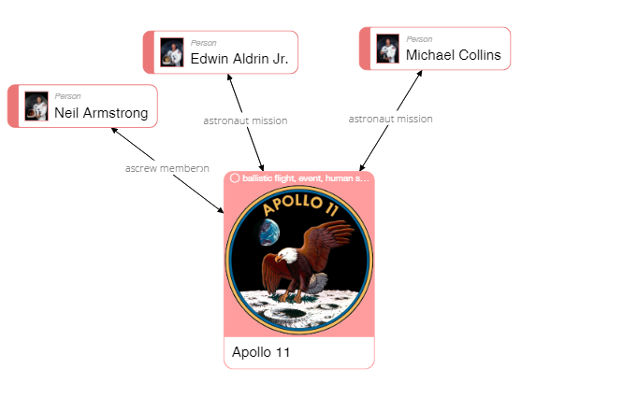

|  |
| --- |
| **Please describe shortly what you see on this diagram? Pay attention only to that information that is understandable or has sense for you.** |
| The participants of Apollo 11 mission |

40

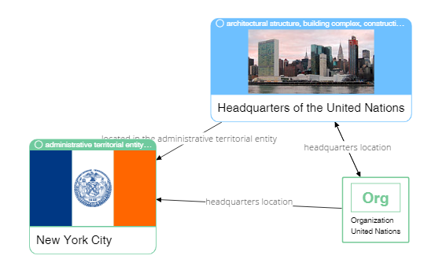

|  |
| --- |
| **Please describe shortly what you see on this diagram? Pay attention only to that information that is understandable or has sense for you.** |
| The location of UN headquarters: New York and the exterior of the building on Manhattan? No concrete address/ |

37

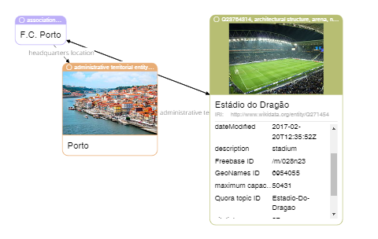

|  |
| --- |
| **Please describe shortly what you see on this diagram? Pay attention only to that information that is understandable or has sense for you.** |
| The location of FC Porto association: the city of Porto and some details about the stadium with a link to its internet resource |